Survey + Analysis Report
Week 2 Deliverable - Needs Assessment

1. Methodology
- Survey title: Student Survey - Learning Needs, Facilities & Inclusion
- Format: Anonymous paper questionnaire, 20 questions across 3 sections
- Sample: 100 students, one class per grade level
- Data collected on learning needs, facility accessibility, and gender/diversity inclusion

2. Key Indicators Overview
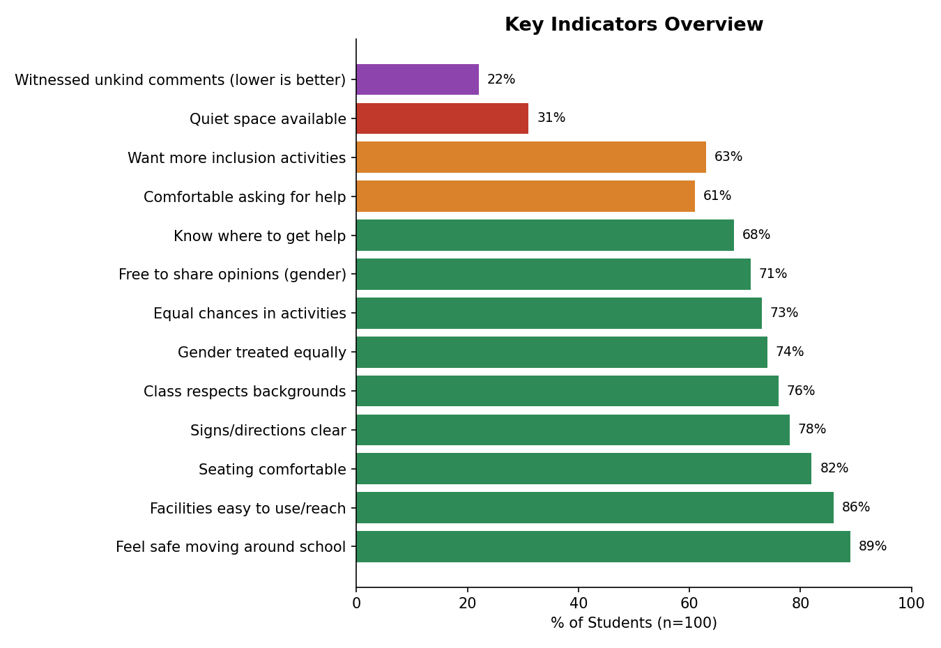

3. Section A: Learning Needs
Question | Response | % of Students
1. Easy to follow lessons? | Always | 52%
 | Sometimes | 38%
 | Rarely | 8%
 | Never | 2%
2. Subject/lesson especially hard? | Yes | 42%
 | No | 58%
4. Comfortable asking teacher for help? | Yes | 61%
 | Sometimes | 30%
 | No | 9%
5. Teacher explains clearly? | Always | 64%
 | Sometimes | 31%
 | Rarely | 5%
6. Enough time for classwork? | Yes | 57%
 | No | 13%
 | Sometimes | 30%
7. Felt left out/teased? | Yes | 17%
 | No | 77%
 | Prefer not to say | 6%
8. Know where to get extra help? | Yes | 68%
 | No | 32%

What Makes Lessons Hard (Q3, open text)
What Makes Lessons Hard (of those who said Yes to Q2) | No. of Students
Difficult concepts/chapters | 18
Lessons move too quickly | 9
Difficulty understanding English/terminology | 7
Need more examples/practice | 5
Difficulty concentrating | 3

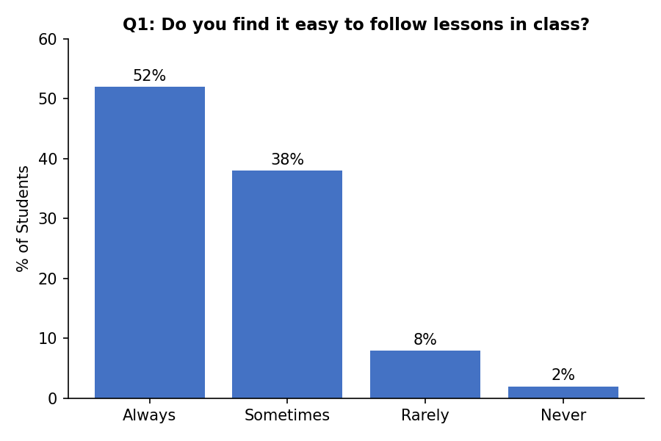

4. Section B: Facilities
Question | Response | % of Students
9. Facilities easy to use/reach? | Yes | 86%
 | No | 6%
 | Not sure | 8%
10. Quiet space available? | Yes | 31%
 | No | 43%
 | Don't know | 26%
11. Feel safe moving around school? | Yes | 89%
 | No | 3%
 | Sometimes | 8%
12. Signs/directions clear? | Yes | 78%
 | No | 8%
 | Not sure | 14%
13. Seating comfortable/easy to use? | Yes | 82%
 | No | 7%
 | Not sure | 11%

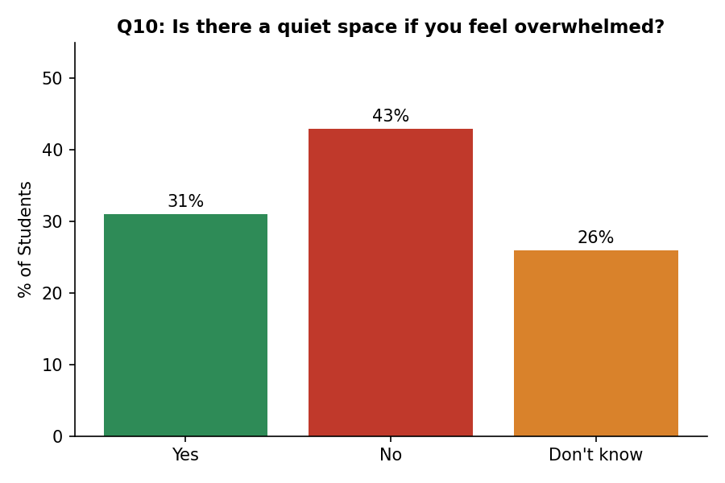

5. Section C: Gender & Diversity
Question | Response | % of Students
14. Boys and girls treated equally? | Yes | 74%
 | No | 10%
 | Not sure | 16%
15. Class respects different backgrounds? | Yes | 76%
 | Somewhat | 19%
 | No | 5%
16. Seen/heard unkind comments? | Yes | 22%
 | No | 72%
 | Prefer not to say | 6%
17. Free to share opinions regardless of gender? | Yes | 71%
 | No | 9%
 | Not sure | 20%
18. Equal chances in activities/sports/leadership? | Yes | 73%
 | No | 11%
 | Not sure | 16%
19. Want more respect & inclusion activities? | Yes | 63%
 | No | 12%
 | Maybe | 25%

6. What Students Want to Change (Q20, open text)
Suggested Change | No. of Students
More activities promoting kindness, respect and inclusion | 24
Ramps/accessible pathways in more areas of the school | 16
Better/cleaner toilets and washroom facilities | 14
More comfortable classroom seating | 10
Handrails near stairs and ramps | 8
More sports and recreational facilities | 8
A quiet/calm space for students | 7
More academic support/remedial classes | 6
Better signage and directions around school | 4
More opportunities for students to express opinions | 3
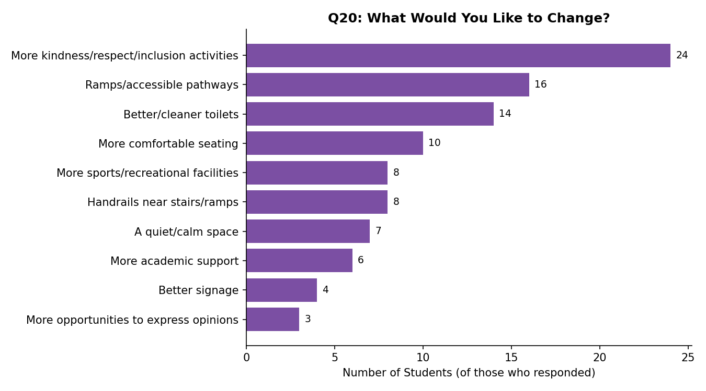

7. Overall Findings
- 86% of students find the classrooms, toilets and play areas easy to use and reach.
- 89% feel safe while moving around the school building and grounds.
- 82% find classroom seating comfortable and accessible.
- 78% feel that school signs and directions are easy to understand.
- Accessibility can be strengthened through additional ramps, accessible pathways and handrails, particularly in areas involving stairs or changes in floor level.
- A quiet/calm space remains an area for improvement, with many students either reporting that there is no such space or that they do not know about one.
- Learning-related responses indicate that academic support and differentiated learning remain important areas of need.
- 22% of students reported witnessing unkind comments related to gender, culture or background, suggesting that inclusion and awareness activities would be beneficial.
- 88% of students either want or might consider more activities focused on respect and inclusion.

8. Recommendations for Week 3-5 Campaign Focus
- Priority 1 - Quiet/Calm Space: With only 31% confirming one exists, this is the clearest facility gap and should be addressed alongside awareness messaging.
- Priority 2 - Inclusion & Respect Activities: 22% have witnessed unkind comments and 88% support more inclusion activities - strong justification for the sensitization campaign's gender/diversity theme.
- Priority 3 - Accessibility Improvements: Ramps, handrails, and accessible pathways were the most-requested facility changes (Q20) and should be flagged to school administration alongside the campaign.
- Priority 4 - Academic Support: 42% find at least one subject especially hard, most often citing difficult concepts and pace - consider pairing the sensitization campaign with peer-support or remedial sessions.

